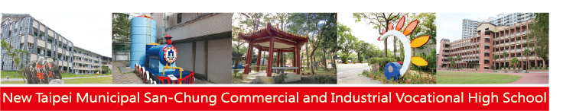

**Guidance**

**Time：2024/02/20（六）**

**Venue：Student Activity Center Various Professional Classroom and Factories**

**SCVS Guid**

**107 Academic year**

**編製**

